Pac-Poly-Marquesas-Tatooing 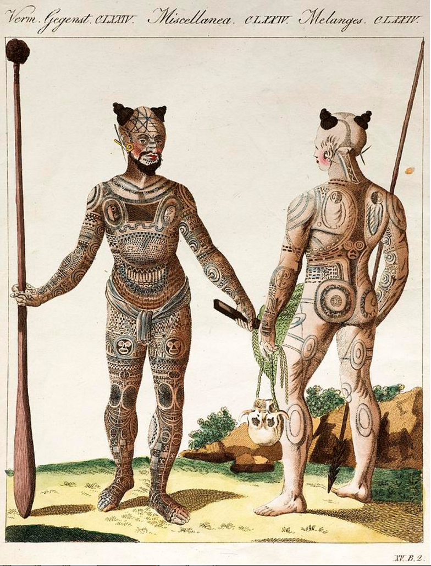 sharpened

